EXPERIMENT 3

1. Take a command line argument and reports on whether it is a directory or a file.

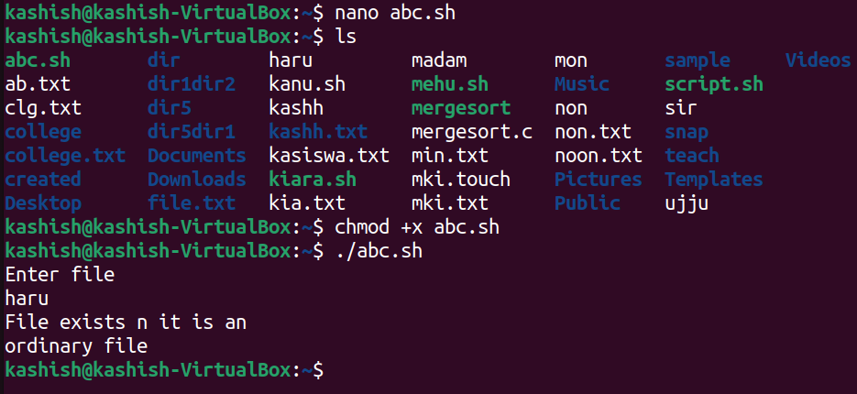

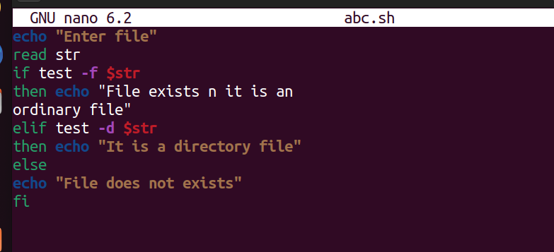

1. Takes the file names as agruments and convert all of them to uppercase.

